NOTICE TO BIDDERS
REQUEST FOR PROPOSALS
Crane County Commissioners Court is accepting sealed proposals for the design, construction, and installation of the following projects for the Baseball Complex:
- Announcer Stands
- Utility Building
- Awnings

Project Scope

Announcer Stands
- Size: 6 x 10 feet, height of 3 steps
- Quantity: 4 announcer stands
- Materials: Metal
- Roofing: Metal
- Completion Timeline

Utility Building
- Size: 30 x 40 feet
- Materials: Metal
- Roofing: Metal
- Completion Timeline

Awnings
- Size: To be determined during site meeting
- Materials: Metal
- Roofing: Metal
- Completion Timeline
- Baseball Complex Plat Link

Proposal Submission Requirements
Each proposal must include:
- Detailed project proposal, including materials and labor breakdown.
- Estimated timeline from commencement to completion.
- Proof of relevant licensing, insurance, and bonding.
- At least three references from similar completed projects.
- Warranty details for both labor and materials.

Bid Submission Instructions
Sealed bids must be clearly labeled as follows: “Bid Proposal – Announcer Stands, Utility Building, Awnings’’

Submission Deadline:
- Date: Monday, July 7, 2025
- Time: No later than 4:00 p.m.
- Address: Crane County Commissioner's Office 201 W. 6th St., Room 102, Crane, Texas 79731

Bid Opening:
- Date: Tuesday, July 8, 2025
- Time: 10:00 a.m.
- Location: Commissioners Court Meeting
- Attendance: Bidders or representatives are encouraged to attend.

Additional Information:
- Crane County reserves the right to reject any or all proposals, waive formalities, and select the proposal deemed in the County’s best interest.
- Late bids will not be accepted.
- For any questions regarding the bid specifications, please call 432-558-1100.

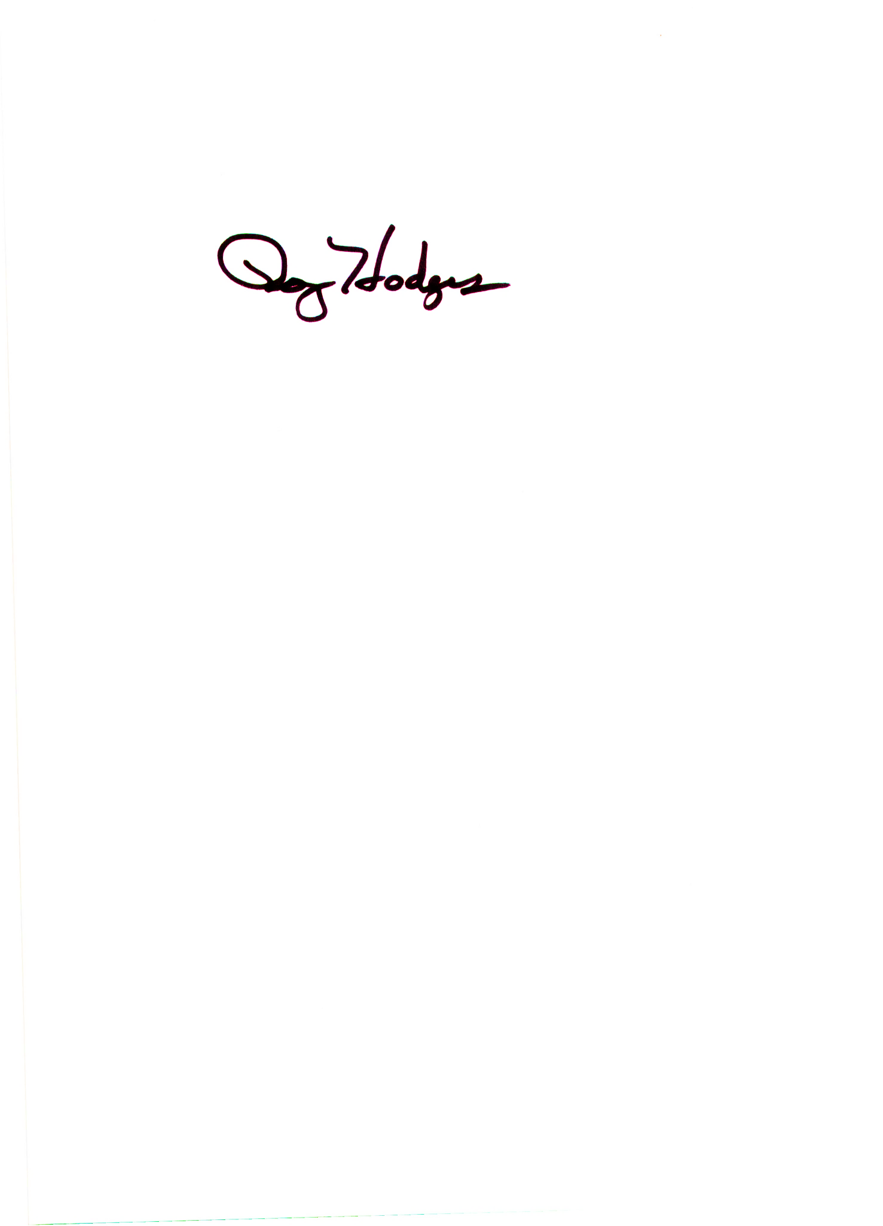
Signed this 16th of June 2025
________________________
Roy Hodges, County Judge
Crane County, Texas

